MongoDB commands

To view all database ‘show dbs’ is used

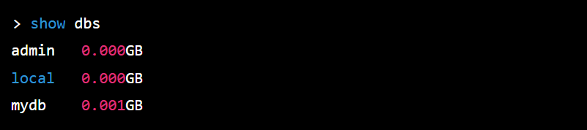

To create database or switch to database ‘use’ command is used



To delete datebase



To create collections in database



To show collections



To delete collection



To insert data

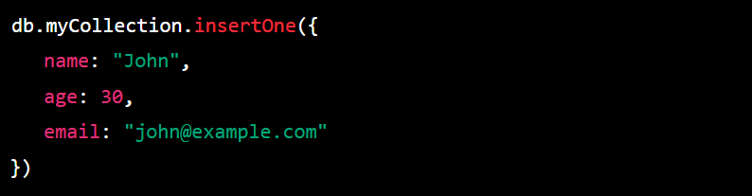

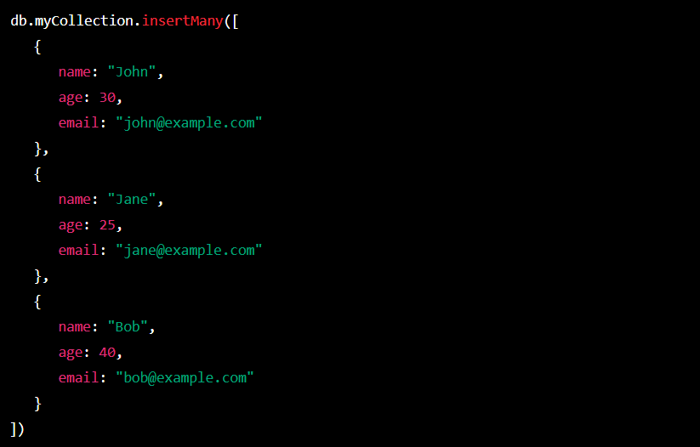

To show all rows in collections





Show all row in collection (prettified)



**Chain method:**

To sort the result



To limit the result



To count the document



To update document in

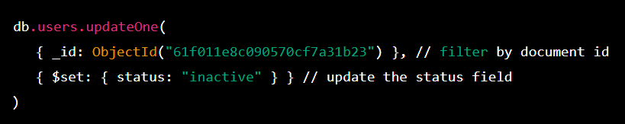

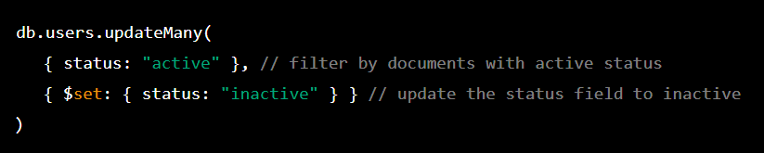

To find one document and update

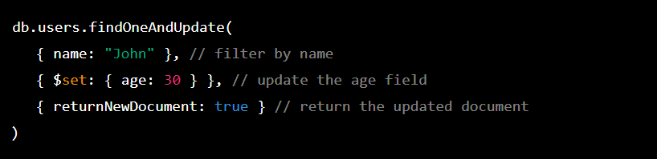

To find one document and replace with other document

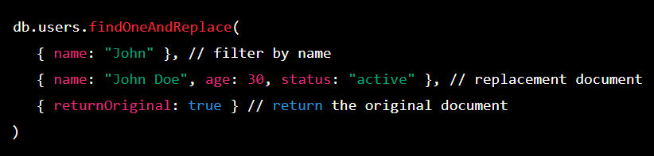

To find document and delete

